***1.Bug Title:* Typo at the Address form field label “Optional” spelled as “optioal”**

***2.Severity :***

* **Low**

***3.Reproducibility***

* **Always**

***4.Bug Type/Category***

* **UI**

***5.Steps to Reproduce***

* **Go to** [**https://qa-assessment.pages.dev/**](https://qa-assessment.pages.dev/)
* **Go to the address field label**

***6.Expected Results***

* **“Optional” should be well spelled**

***7.Actual Results***

* **“Optional” is wrongly spelled**

***8.Screenshot/screenrecord link of bug***

**-screenshot**

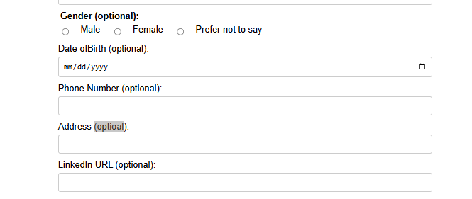

***9.Device Information***

**- Occurs on all Devices**

**-Connection type and speed: Mobile data / 17Mbps**